In this chapter, we will learn how to enable/disable the Authentication, and how to bind the ArangoDB to the Public Network Interface.

# arangosh --server.endpoint tcp://127.0.0.1:8529 --server.database "_system"

It will prompt you for the password saved earlier −

Please specify a password:

Use the password you created for root, at the configuration.

You can also use curl to check that you are actually getting HTTP 401 (Unauthorized) server responses for requests that require authentication −

# curl --dump - http://127.0.0.1:8529/_api/version

Output

HTTP/1.1 401 Unauthorized

X-Content-Type-Options: nosniff

Www-Authenticate: Bearer token_type = "JWT", realm = "ArangoDB"

Server: ArangoDB

Connection: Keep-Alive

Content-Type: text/plain; charset = utf-8

Content-Length: 0

To avoid entering the password each time during our learning process, we will disable the authentication. For that, open the configuration file −

# vim /etc/arangodb3/arangod.conf

You should change the color scheme if the code is not properly visible.

:colorscheme desert

Set authentication to false as shown in the screenshot below.

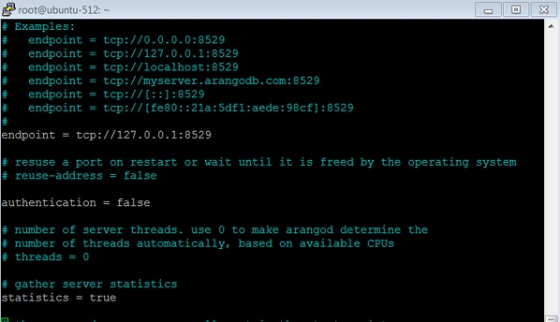

Restart the service −

# service arangodb3 restart

On making the authentication false, you will be able to login (either with root or created user like **Harry** in this case) without entering any password in **please specify a password**.

Let us check the **api** version when the authentication is switched off −

# curl --dump - http://127.0.0.1:8529/_api/version

Output

HTTP/1.1 200 OK

X-Content-Type-Options: nosniff

Server: ArangoDB

Connection: Keep-Alive

Content-Type: application/json; charset=utf-8

Content-Length: 60

{"server":"arango","version":"3.1.27","license":"community"}